

The White House

Office of the Press Secretary

For Immediate Release

September 28, 2017

Readout of Second Lady Karen Pence’s visit to New Directions for Veterans in Los Angeles, California

Today, Second Lady Karen Pence visited New Directions for Veterans (NDVets) in Los Angeles, California. She was accompanied by Mrs. Hollyanne Milley, wife of the Army’s Chief of Staff, General Mark Milley.

Upon arrival, Mrs. Pence and Mrs. Milley were greeted by NDVets Co-Founder, Larry Williams, CEO, Colonel (Retired) Yvette Kelley, **Director of Clinical Services, Matthew Rohr,** Vice President of Development, Molly Ann Mroczynski, Chief Program Officer, Dr. Susan Michael, and art therapist, Tara Beach. After the greeting, Mrs. Pence and Mrs. Milley received a brief overview of the services offered by New Directions for Veterans, including an overview of the art therapy program.

Following the overview about NDVets, two veterans in the art therapy program shared some of their artwork with Mrs. Pence and Mrs. Milley. After the meeting with the veterans, art therapist, Tara Beach presented a case summary, which consisted of several pieces of artwork created by one of her clients who suffered from Post-traumatic Stress Disorder. Before the meeting concluded, the art therapist shared information about the art therapy at NDVets.

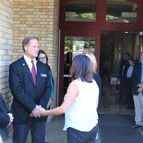

Second Lady Karen Pence meets Director of Clinical Services, Matthew J. Rohr, M.S., LMFT

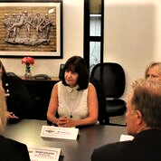

Roundtable discussion about veteran mental health.

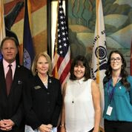

Director of Clinical Services, Matthew J. Rohr, M.S., LMFT, CEO Colonel Yvette Kelly, Second Lady Karen Pence and Art Therapist, Tara Beach.